|  |  |
| --- | --- |
| **WC Logo.emf** | **Staff Report to the County Commission**  *Weber County Planning Division* |
|  | |

****Synopsis****

****Application Information****

**Application Request:** Consideration and action on a request for final approval of Highlands Bluff Estates Phase 1, 1st Amendment, consisting of 12 residential lots.

**Agenda Date: Tuesday, February 08, 2022**

**Applicant:** Moore Homes LC & Celebrity Const. Inc., owner

**File Number:** LVH 091820

****Property Information****

**Approximate Address:** 6224 S 2225 E, Ogden

**Project Area:** 4.59 Acres

**Zoning:** Single-family residential zone (R-1-12)

**Existing Land Use:** Vacant

**Proposed Land Use:** Residential

**Parcel ID:** 07-335-0001

**Township, Range, Section:** T5N, R1W, Sections 23

****Adjacent Land Use****

**North:** Residential **South:** Residential

**East:** Residential **West:** Residential

****Staff Information****

**Report Presenter:** Felix Lleverino

flleverino@co.weber.ut.us

801-399-8767

**Report Reviewer: SB**

Applicable Land Use Codes

* Title 101 (General Provisions) Chapter 1 (Definitions)
* Title 104 (Zones) Chapter 12 (Single-family residential zone R-1-12)
* Title 106 (Subdivisions) Chapter 1 (General Provisions) Section 5 (Final Plat Requirements)
* Title 108 (Standards) Chapter 22 (Natural Hazard Areas)

Development History

This property was rezoned from RE-15 to R-1-12 on July 28th, 2020. This subdivision amendment will subdivide lot 1 of Highlands Bluff Estates Phase 1. The Highlands Bluff Estates Phase 1 was platted on January 7th, 1988.

Preliminary approval from the Western Weber Planning Commission was granted on November 10, 2020.

A positive recommendation from the Planning Commission for final approval was granted on April 13th, 2021.

Highlands Bluff Estates Phase 1 1st Amendment will be presented before the County Commission on February 8th, 2022.

Background and Summary

The applicant is requesting final approval of a 12-lot subdivision, located at approximately 6224 S 2225 E Uintah Highlands. The public right-of-way for this development will intersect with 2225 East Street. The public road will terminate at a cul-de-sac. Curb, gutter, and sidewalk are planned for this development.

This report includes a Subdivision Improvement Agreement with an escrow certificate for $104,491.52 (see Exhibit B).

This proposal has been reviewed against the current Land Use Code of Weber County Utah (LUC), the standards of the R-1-12 zone found in LUC §104-12. The following section is a brief analysis of this project against current land use regulations.

Analysis

*General Plan*: This proposal conforms with South East Western Weber County Plan by allowing one single-family dwelling per 12,000 square feet. (see page 65 of the general plan).

*Zoning*: The property is located in the R-1-12 Zone. The purpose of this zone is stated in the LUC §104-12-1.

*“The purpose of the R-1-12, R-1-10 Zone classification is to provide regulated areas for single-family residential use at two different low-density levels.”*

Each lot meets the zoning requirement of 12,000 square feet minimum and 90 feet of the lot width.

*Natural Hazards*: A Geotechnical study has been prepared by CMT Engineering Laboratories, Dated January 13th, 2020, with Project Number 13895. The report provides valuable information regarding soil types, site grading, soil removal, structural fill, compaction, and types and severity of hazards present on the property. Special attention should be taken to the report by the civil engineers who will be designing the roadway and structural engineers who will draw plans for residential development. Page 12 states that residential development should be designed for seismic category D.

*Flood Zone*: This parcel is within a Zone X flood area, and determined to be outside the 500-year flood level.

*Sanitary System and Culinary Water*: Uintah Highlands Improvement District has provided a letter stating that water and sanitary services are available for each lot within this proposed subdivision.

*Minor Terminal Streets*: The County Engineering standard right-of-way width is 60’. With the County Engineer’s approval, the right-of-way width may be reduced to 50’ under LUC 106-2-2 (c), (d). The County Engineering Department will accept the proposed 55’ ROW. The plan includes curb, gutter, parking strip, and sidewalk.

*Secondary Water*: The secondary water line connection is at the northeast corner of the property. The existing water allotment of 7.5 acre-feet per year is sufficient for this development. Weber Basin also recommends water-wise landscaping design for lots within this development.

*Review Agencies*: The Weber County Fire District has approved this proposal with the condition that Weber Fire discusses with the developer the possibility of placing a new fire hydrant. Weber County Surveying has approved this plat with the condition the developer enter into a Monument Improvement Agreement. Weber County Engineering has approved the civil drawings and the final cost estimate.

Staff Recommendation

Staff recommends final approval of the Highlands Bluff Estates Phase 1, 1st Amendment Subdivision, consisting of 12 lots. This recommendation is based on the fulfillment of County review agency requirements and the following conditions:

1. Sidewalk shall be built on 6225 S, 6235 S, and 2225 E under the direction of the County Engineering Department.
2. The Monument Improvement Agreement is finalized with the County Surveyor’s Office before recording the subdivision plat.

This recommendation is based on the following findings:

1. The proposed subdivision complies with South East Western Weber County Plan.
2. The proposed subdivision complies with the applicable County codes.

Exhibits

1. Highlands Bluff Estates Phase 1, 1st Amendment Subdivision Plat
2. Subdivision Improvement Agreement

Area Map

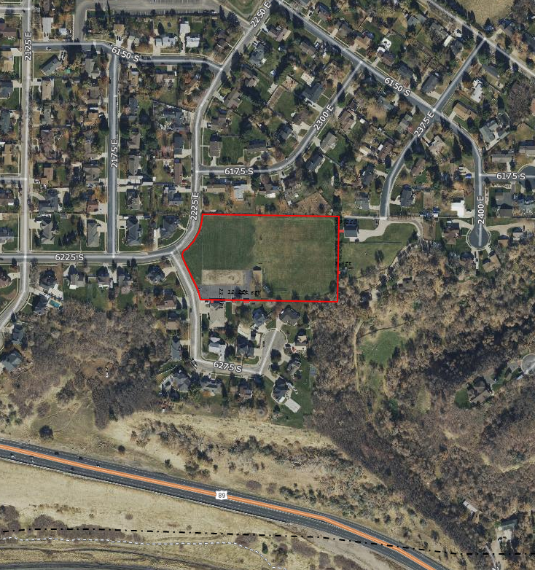

Exhibit A

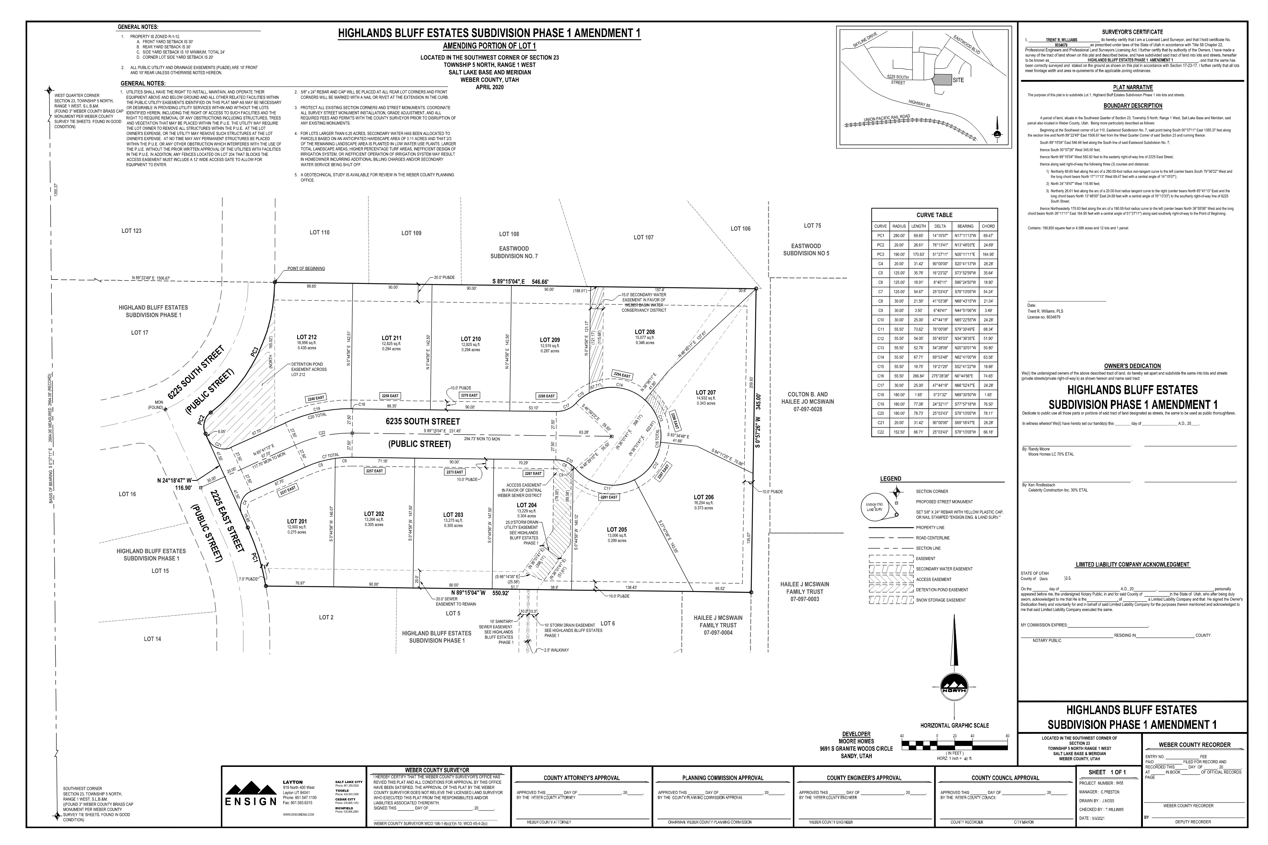

Exhibit B

**WEBER COUNTY**

**IMPROVEMENTS GUARANTEE AGREEMENT**

**THIS AGREEMENT** (herein “Agreement”) is entered into this day of , 20 ,

**\* * * * * P A R T I E S * * * * \***

**“APPLICANT”:**

a(n): (corporation, limited liability company, partnership, individual).

address: city: state: zip:

telephone: ( ) , facsimile: ( )

**“COUNTY”:** Weber County, a political subdivision of the State of Utah,

2380 Washington BLVD, Ogden, UT 84401,

(801) 399-8374.

**\* * * * * R E C I T A L S * * * * \***

**WHEREAS,** APPLICANT desires to post the following improvement guarantee(s) (check):

Off-site improvement guarantee

On-site improvement guarantee

with the COUNTY for **Highlands Bluff Estates Phase 1 1st Amendment**

(description or name of Project)

located at **Approximately 6224 S 2225 East, Ogden Utah**

(address of Project)

**WHEREAS,** COUNTY ordinances require APPLICANT to guarantee the construction of certain improvements prior to either the recordation of the above described subdivision plat or the actual issuance of any permit(s) or approval(s) related to the above-described Project; and

**WHEREAS,** the terms of either the subject subdivision plat approval or the issuance of the subject permit(s)/approval(s) require APPLICANT to complete the following improvements, (herein “the Improvements”) (check one and complete):

specified in Exhibit B , attached hereto and incorporated herein by this reference;

- or -

described as follows: ; and

**WHEREAS,** COUNTY will not record the subject subdivision or grant the subject permit(s)/approval(s) until adequate provision has been made to guarantee completion of the Improvements and to warrant the Improvements shall be maintained and remain free from any defects or damage, which improvements and required warranty are estimated to cost the amount set forth herein, and which improvements shall be installed in accordance with the specifications of COUNTY, and inspected by COUNTY;

**NOW THEREFORE,** For good and valuable consideration, the parties agree as follows:

**\* * * * * TERMS AND CONDITIONS * * * * \***

1. **PURPOSE FOR AGREEMENT.** The parties hereto expressly acknowledge that the purpose of this Agreement is not only to guarantee the proper completion of the Improvements named herein, but also, among other things, to eliminate and avoid the harmful effects of unauthorized subdivisions and other land developments which may leave property or improvements improperly completed, undeveloped or unproductive.

2. **UNRELATED OBLIGATIONS OF APPLICANT.** The benefits and protection of the Proceeds specified herein shall inure solely to COUNTY and not to third parties, including, but not limited to, lot purchasers, contractors, subcontractors, laborers, suppliers, or others. COUNTY shall not be liable to claimants or others for obligations of APPLICANT under this Agreement. COUNTY shall further have no liability for payment of any costs or expenses of any party who attempts to make a claim under this Agreement, and shall have under this Agreement no obligation to make payments to, give Notices on behalf of, or otherwise have obligations to any alleged claimants under this Agreement.

3. **AGREEMENT DOCUMENTS.** All data which is used by COUNTY to compute the cost of or otherwise govern the design and installation of the Improvements is hereby made a part of this Agreement, and is incorporated herein by this reference. This Agreement incorporates herein by reference any subject subdivision plat, plan, construction drawing, permit, condition of approval, and any and all other relevant data and specifications required by the Weber County Land Use Code.

4. **COMPLETION DATE.** APPLICANT shall complete the Improvements: (check one and complete)

within a period of 1  Year(s)  Months (check one) from the date this Agreement was entered into;

- or -

as specified in Exhibit (Completion Schedule), attached hereto and incorporated herein by this reference.

5. **FEES.**  APPLICANT agrees to pay all Fees required by COUNTY for the entire Project prior to the issuance of any subsequent permit or approval within the Project.

6. **SPECIFIC PERFORMANCE.** APPLICANT has entered into this Agreement with COUNTY for the purpose of guaranteeing construction of the Improvements and payment of the Fees. COUNTY shall be entitled to specifically enforce APPLICANT'S obligation under this Agreement to construct and install the Improvements in a manner satisfactory to COUNTY, and to pay the Fees.

7. **APPLICANT’S INDEPENDENT OBLIGATION.** APPLICANT EXPRESSLY ACKNOWLEDGES, UNDERSTANDS AND AGREES that its obligation to complete and warrant the Improvements and pay the Fees and fulfill any other obligation under this Agreement, COUNTY ordinances, or other applicable law is independent of any obligation or responsibility of COUNTY, either express or implied. APPLICANT agrees that its obligation to complete and warrant the Improvements and pay the Fees is not and shall not be conditioned upon the commencement of actual construction work in the subdivision or development or upon the sale of any lots or part of the subdivision or development. APPLICANT further acknowledges (a) that its contractual obligation to complete and warrant the Improvements and pay the Fees pursuant to this Agreement is independent of any other remedy available to COUNTY to secure proper completion of the Improvements and payment of the Fees; (b) that APPLICANT shall not assert as a defense that COUNTY has remedies against other entities or has other remedies in equity or at law that would otherwise relieve APPLICANT of its duty to perform as outlined in this Agreement or preclude COUNTY from requiring APPLICANT’S performance under this Agreement; (c) that APPLICANT has a legal obligation, independent of this Agreement, to timely complete and pay for the Improvements in full and timely pay the Fees in full; and (d) should APPLICANT Default under this Agreement in any degree, APPLICANT agrees to compensate COUNTY for all costs, including Incidental Costs, related to APPLICANT’S failure to perform its obligation to complete and warrant the Improvements or pay the Fees to the extent that such costs are not adequately covered by the Proceeds (“Proceeds” defined in paragraph 10).

8. **INCIDENTAL COSTS.** “Incidental Costs”, as used in this Agreement, shall mean engineering and architect fees, administrative expenses, court costs, attorney’s fees (whether incurred by in-house or independent counsel), insurance premiums, mechanic’s or materialmen’s liens, and any other cost and interest thereon incurred by COUNTY, occasioned by APPLICANT’S Default under this Agreement.

9. **DEFAULT.** “Default,” as used in this Agreement, shall mean, in addition to those events previously or subsequently described herein, a party’s failure to perform, in a timely manner, any obligation, in whole or in part, required of such party by the terms of this Agreement or required by COUNTY ordinance or other applicable law. In addition, the following shall also be considered Default on the part of APPLICANT: APPLICANT'S abandonment of the Project, as determined by COUNTY; APPLICANT'S insolvency, appointment of a receiver, or filing of a voluntary or involuntary petition in bankruptcy; APPLICANT’S failure to file with COUNTY a renewed Financial Guarantee, as defined in paragraph 10, more than 60 days before a Financial Guarantee will expire, unless APPLICANT’S obligations have been terminated under paragraph 36(b); APPLICANT’S Escrow Repository’s or Financial Institution’s insolvency, appointment of a receiver, filing of a voluntary or involuntary petition in bankruptcy, or failure to perform under the terms of this agreement; the commencement of a foreclosure proceeding against the Project property; or the Project property being conveyed in lieu of foreclosure.

The occurrence of such shall give the other party or parties the right to pursue any and all remedies available at law, in equity, or otherwise available pursuant to the terms of this Agreement. Only the parties hereto are authorized to determine Default. Default shall not be declared prior to the other party receiving written notice.

10. **GUARANTEE OF IMPROVEMENTS.** APPLICANT hereby files, as an independent guarantee (herein “Financial Guarantee”) with COUNTY for the purpose of insuring construction and installation of the Improvements and payment of the Fees, one of the following (check one and complete applicable information):

CASH CERTIFICATE, identified by the following:

Escrow Account: ,

Escrow Account Repository: ,

IRREVOCABLE LETTER OF CREDIT (herein the "Letter of Credit"), identified by the following:

Letter of credit account or number: ,

Financial Institution: ,

The Financial Guarantee shall be in the amount of one hundred ten percent (110%) of the County Engineer’s Cost Estimate (see also Exhibit A attached hereto). The Escrow Certificate or Letter of Credit shall be issued in favor of COUNTY to the account of APPLICANT herein, in the amount of **$104,491.52** (herein the "Proceeds"), and is made a part of this Agreement as Exhibit C (Escrow Certificate or Letter of Credit).

11. **PARTIAL RELEASE OF PROCEEDS.** As the Improvements are initially accepted by COUNTY and the Fees are paid, the APPLICANT may submit written request to COUNTY for authorization for a partial release of Proceeds. APPLICANT is only entitled to make a request once every 30 days. The amount of any release shall be determined in the sole discretion of COUNTY. No release shall be authorized by COUNTY until such time as COUNTY has inspected the Improvements and found them to be in compliance with COUNTY standards and verified that the Fees have been paid. Payment of Fees or completion of Improvements, even if verified by COUNTY, shall not entitle APPLICANT to an automatic authorization for a release of the Proceeds. At no time may APPLICANT request a release of funds directly from Escrow Account Repository or Financial Institution.

12. **NOTICE OF DEFECT.** COUNTY will provide timely notice to APPLICANT whenever an inspection reveals that an Improvement does not conform to the standards and specifications shown on the Improvement drawings on file in COUNTY’s Engineering and Surveyor's Office or is otherwise defective. The APPLICANT will have 30 days from the issuance of such notice to cure or substantially cure the defect.

13. **FINAL ACCEPTANCE.** Notwithstanding the fact that Proceeds may be released upon partial completion of the Improvements, neither any partial release nor any full release of the Proceeds shall constitute final acceptance of the Improvements by COUNTY. Final acceptance of the Improvements shall be official only upon written notice to APPLICANT from COUNTY expressly acknowledging such and only after APPLICANT provides a policy of title insurance, where appropriate, for the benefit of the County showing that the APPLICANT owns the improvement in fee simple and that there are no liens, encumbrances, or other restrictions on the improvement unacceptable to the County in its reasonable judgment.

14. **WARRANTY OF IMPROVEMENTS.** Following initial acceptance of the Improvements, APPLICANT hereby warrants that the Improvements shall be maintained by APPLICANT and remain free from defects or damage as determined by COUNTY, such that the Improvements continue to meet COUNTY standards for _1___ years following said initial acceptance.

15. **RETAINAGE.** APPLICANT expressly agrees that, notwithstanding any partial release of any of the Proceeds, the Proceeds shall not be released below 10% of the estimated cost of the Improvements (herein the “Retainage”), as specified herein, for the timeframe specified in paragraph 14. The Retainage shall be held to insure that the Improvements do not have any latent defects or damage as determined by COUNTY, such that the Improvements do not continue to meet COUNTY standards for the timeframe specified in paragraph 14. Notwithstanding said Retainage, APPLICANT shall be responsible for bringing any substandard, defective, or damaged Improvements to COUNTY standard if the Retainage is inadequate to cover any such Improvements.

16. **APPLICANT INDEMNIFICATION.** APPLICANT agrees to indemnify, defend, and save harmless COUNTY, its elected officials, officers, employees, agents, and volunteers from and against any and all liability which may arise as a result of the installation of the Improvements prior to COUNTY'S initial acceptance of the Improvements as defined herein, and from and against any and all liability which may arise as a result of any Improvements which are found to be defective during the warranty period covered by this Agreement. With respect to APPLICANT'S agreement to defend COUNTY, as set forth above, COUNTY shall have the option to either provide its own defense, with all costs for such being borne by APPLICANT, or require that APPLICANT undertake the defense of COUNTY.

17. **FINAL RELEASE OF PROCEEDS.** In the event the Improvements have been installed to the satisfaction of COUNTY and the Fees have been paid pursuant to this Agreement and COUNTY ordinances within the above stated time period(s), COUNTY agrees to execute a written release to Escrow Account Repository or Financial Institution of the remaining Proceeds.

18. **DEMAND FOR AND USE OF PROCEEDS.** In the event APPLICANT fails to install Improvements to the satisfaction of COUNTY, or the Fees are not paid pursuant to this Agreement and COUNTY ordinances within the above stated time period(s), or APPLICANT Defaults on any obligation under this Agreement or COUNTY ordinances, as determined at the sole discretion of COUNTY, COUNTY shall send Notice of APPLICANT’S Default to Escrow Account Repository or Financial Institution with a written demand for the release of Proceeds. COUNTY may, at its sole discretionary option, use and expend all the Proceeds or such lesser amount as may be estimated by COUNTY to be necessary to complete Improvements, pay Fees, and/or reimburse COUNTY for Incidental Costs as required herein.. COUNTY may, at its sole discretionary option, convert the Proceeds to a COUNTY held cash escrow for future satisfactory installation of Improvements.

19. **INADEQUATE PROCEEDS.** If the Proceeds are inadequate to pay the cost of the completion of the Improvements according to COUNTY standards or to pay the Fees or to compensate for Incidental Costs, for whatever reason, including previous reductions, APPLICANT shall be responsible for the deficiency independent of the Financial Guarantee. Additionally, no further approvals, permits or business licenses shall be issued, and any existing approvals, permits or business licenses applicable to the location of the Improvements may be immediately suspended or revoked by COUNTY'S Community and Economic Development Director until the Improvements are completed and the Fees are paid, or, until a new guarantee acceptable to the COUNTY has been executed to insure completion of the remaining Improvements and payment of the Fees. Furthermore, the cost of completion of the Improvements shall include reimbursement to COUNTY for all costs including, but not limited to, construction costs and any Incidental Costs incurred by COUNTY in completing the Improvements or collecting the Proceeds.

20. **ACCESS TO PROPERTY.** Should COUNTY elect to use the Proceeds to complete the Improvements, APPLICANT herein expressly grants to COUNTY and any contractor or other agent hired by COUNTY the right of access to the Project property to complete the Improvements.

21. **IMPROVEMENT STANDARDS.** Improvements shall be done according to the specifications and requirements of the COUNTY. All work shall be subject to the inspection of COUNTY. Any questions as to conformity with COUNTY specifications or standards, technical sufficiency of the work, quality, and serviceability shall be decided by the County Engineer. The County Engineer’s decision shall be final and conclusive.

22. **SUBSTANDARD IMPROVEMENTS.** Should any Improvements prove to be substandard or defective within the timeframe specified in paragraph 14, COUNTY shall notify APPLICANT in writing of such substandard or defective Improvements. APPLICANT shall then have 15 days from Notice from the COUNTY in which to commence repair of the Improvements, and a reasonable amount of time, as determined by COUNTY, which shall be specified in the Notice, to complete repair of the Improvements. Should APPLICANT fail to either commence repair of the Improvements or complete repair of the Improvements within the required time periods, COUNTY may exercise its option to remedy the defects and demand payment for such from APPLICANT, should the Proceeds be insufficient to cover the costs incurred by COUNTY.

23. **INSURANCE.** Should COUNTY elect to install, complete, or remedy any defect or damage in the Improvements, APPLICANT shall be responsible for the payment of the premium for an insurance policy covering any liability, damage, loss, judgment, or injury to any person or property, including, but not limited to, damage to APPLICANT or its property as a result of the work of any contractor or agent hired by COUNTY to complete or remedy the Improvements. The minimum dollar amount and the scope of coverage of the insurance policy shall be determined and set by COUNTY. APPLICANT shall indemnify, defend, and hold harmless COUNTY, its officers, employees, and agents for any liability which exceeds the insurance policy limit. COUNTY, at its option, may collect and expend the Proceeds to make the premium payments should APPLICANT fail to pay said premium. No permit, approval or business license shall be issued by COUNTY, and any existing permit, approval, or business license shall be suspended until said premium is initially paid and a bond is in place to cover subsequent payments.

24. **NOTICE.** Notice to any party herein shall be mailed or delivered to the address shown in this Agreement. The date Notice is received at the address shown in this Agreement shall be the date of actual Notice, however accomplished.

25. **MECHANIC/MATERIAL LIENS.** Should COUNTY elect to complete or remedy the Improvements, APPLICANT shall indemnify, defend, and hold harmless COUNTY from and against any liability which exceeds the Proceeds for the payment of any labor or material liens as a result of any work of any contractor (including subcontractors and materialmen of any such contractor or agent) hired by COUNTY or which may arise due to either a defect in or failure of this Agreement or insufficient Proceeds to cover such costs.

26. **WAIVER.** The failure by any party to insist upon the immediate or strict performance of any covenant, duty, agreement, or condition of this Agreement or to exercise any right or remedy consequent upon a Default thereof shall not constitute a waiver of any such Default or any other covenant, agreement, term, or condition. No waiver shall affect or alter the remainder of this Agreement, but each and every other covenant, agreement, term, and condition hereof shall continue in full force and effect with respect to any other then existing or subsequently occurring Default.

27. **ATTORNEY’S FEES.** In the event there is a Default under this Agreement and it becomes reasonably necessary for any party to employ the services of an attorney in connection therewith, either with or without litigation, on appeal or otherwise, the losing party to the controversy shall pay to the successful party reasonable attorney’s fees incurred by such party, and, in addition, such costs and expenses as are incurred in enforcing this Agreement.

28. **TIME IS OF THE ESSENCE.** Time is of the essence of this Agreement. In case either party shall Default on its obligations at the time fixed for the performance of such obligations by the terms of this Agreement, the other party may pursue any and all remedies available in equity or law.

29. **GOVERNING LAW.** This Agreement shall be interpreted pursuant to, and the terms thereof governed by, the laws of the State of Utah. This Agreement shall be further governed by COUNTY ordinances in effect at the time of the execution of this Agreement. However, the parties expressly acknowledge that any subdivision or other development regulations enacted after the execution of this Agreement, which are reasonably necessary to protect the health, safety, and welfare of the residents of COUNTY, shall also apply to the subdivision or development which is the subject of this Agreement.

30. **SUCCESSORS.** “APPLICANT” and “COUNTY,” as used in this Agreement, shall also refer to the heirs, executors, administrators, successors, or assigns of APPLICANT and COUNTY respectively.

31. **INDUCEMENT.** The making and execution of this Agreement has been induced by no representations, statements, warranties, or agreements other than those herein expressed.

32. **INTEGRATION.** This Agreement embodies the entire understanding of the parties, and there are no further or other agreements or understandings, written or oral, in effect between the parties relating to the subject matter herein.

33. **MODIFICATION.** Except as otherwise authorized by this Agreement, this instrument may be amended or modified only by an instrument of equal formality signed by the respective parties.

34. **CAPTIONS.** The titles or captions of this Agreement are for convenience only and shall not be deemed in any way to define, limit, extend, augment, or describe the scope, content, or intent of any part or parts of this Agreement.

35. **SEVERABILITY.** If any portion of this Agreement is declared invalid by a court of competent jurisdiction, the remaining portions shall not be affected thereby, but shall remain in full force and effect.

36. **TERMINATION.**

1. APPLICANT cannot unilaterally terminate its obligations under this Agreement.
2. If, under the terms of this Agreement, COUNTY releases the full amount of the Proceeds or demands and receives the full remaining amount of the Proceeds, then APPLICANT’S obligations under paragraphs 4 and 10 shall terminate.
3. All rights and obligations in this Agreement that are not terminated under sub-paragraph (b) shall survive until all applicable statutes of limitations have run with respect to the types of claims that may be associated with those rights and obligations.
4. The entire Agreement shall terminate when all applicable statutes of limitations have run or when the parties jointly execute an agreement to terminate this Agreement.

37. **CONFLICT.** Any conflict between this Agreement and its exhibits or any other document shall be interpreted against the exhibit or other document and in favor of statements made in the numbered paragraphs of this Agreement.

**WHEREUPON,** the parties hereto have set their hands the day and year first above written.

**“APPLICANT”**

By:

Applicant Signature Date

_________________________________ ________________________________

Applicant Signature Date

Title:

Title: _____________________________________________________________________________

(Signature must be notarized on following pages.)

**"COUNTY”**

By:

Commission Chair Date

**ATTEST:**

County Clerk Date:

**APPROVED AS TO CONTENT:**

By

Planning Division Director Date

By

County Engineer Date

By

County Treasurer Date

**APPROVED AS TO FORM:**

By

County Attorney Date

**APPLICANT NOTARIZATION**

**COMPLETE ONLY IF APPLICANT IS AN INDIVIDUAL**

State of )

:ss

County of )

On this day of , 20 , personally appeared before me

*[name of person(s)]*, whose identity is personally known to me or proved to me on the basis of satisfactory evidence to be the person(s) whose name(s) is/are subscribed to this instrument, and acknowledged that he/she/they executed the same.

Notary Public

**COMPLETE ONLY IF APPLICANT IS A CORPORATION**

State of )

:ss

County of )

On this day of , 20 , personally appeared before me

*[name of person(s)]*, whose identity is personally known to me or proved to me on the basis of satisfactory evidence, and who affirmed that he/she is the *[title]*,

of *[name of corporation]*, a corporation, and said document was signed by him/her in behalf of said corporation by authority of its bylaws or of a Resolution of its Board of Directors, and he/she acknowledged to me that said corporation executed the same.

Notary Public

**COMPLETE ONLY IF APPLICANT IS A PARTNERSHIP**

State of )

:ss

County of )

On this day of , 20 , personally appeared before me

*[name of person(s)]*, whose identity is

personally known to me or proved to me on the basis of satisfactory evidence, and who affirmed that he/she is the

*[title]*, of *[name of partnership]*,

a partnership, and that the foregoing instrument was duly authorized by the partnership at a lawful meeting held or by authority of its bylaws and signed in behalf of said partnership.

Notary Public

**COMPLETE ONLY IF APPLICANT IS A LIMITED LIABILITY COMPANY**

State of )

:ss

County of )

On this day of , 20 , personally appeared before me

*[name of person(s)]*, whose identity is personally known to me or proved to me on the basis of satisfactory evidence, and who affirmed that he/she is the *[title],*

of  *[name of LLC]*, limited liability company, by authority of its members or its articles of organization, and he/she acknowledged to me that said limited liability company executed the same.

Notary Public

Exhibit A: County Engineer-Approved Cost Estimate

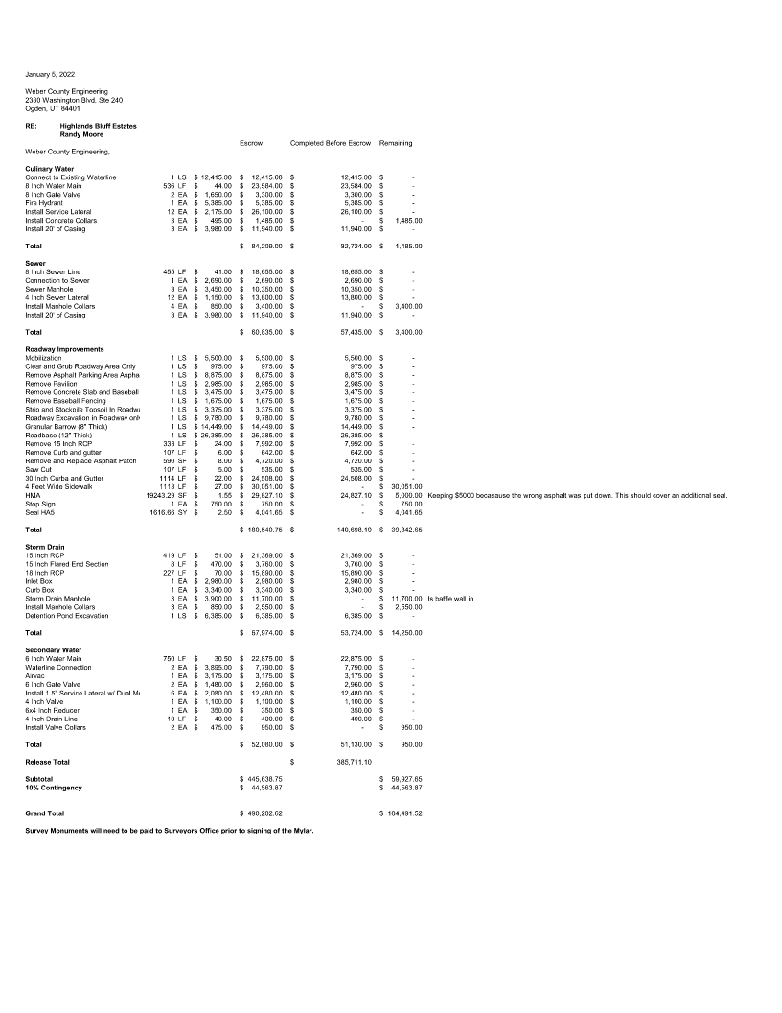

Exhibit B: County Engineer-Approved Construction Drawings

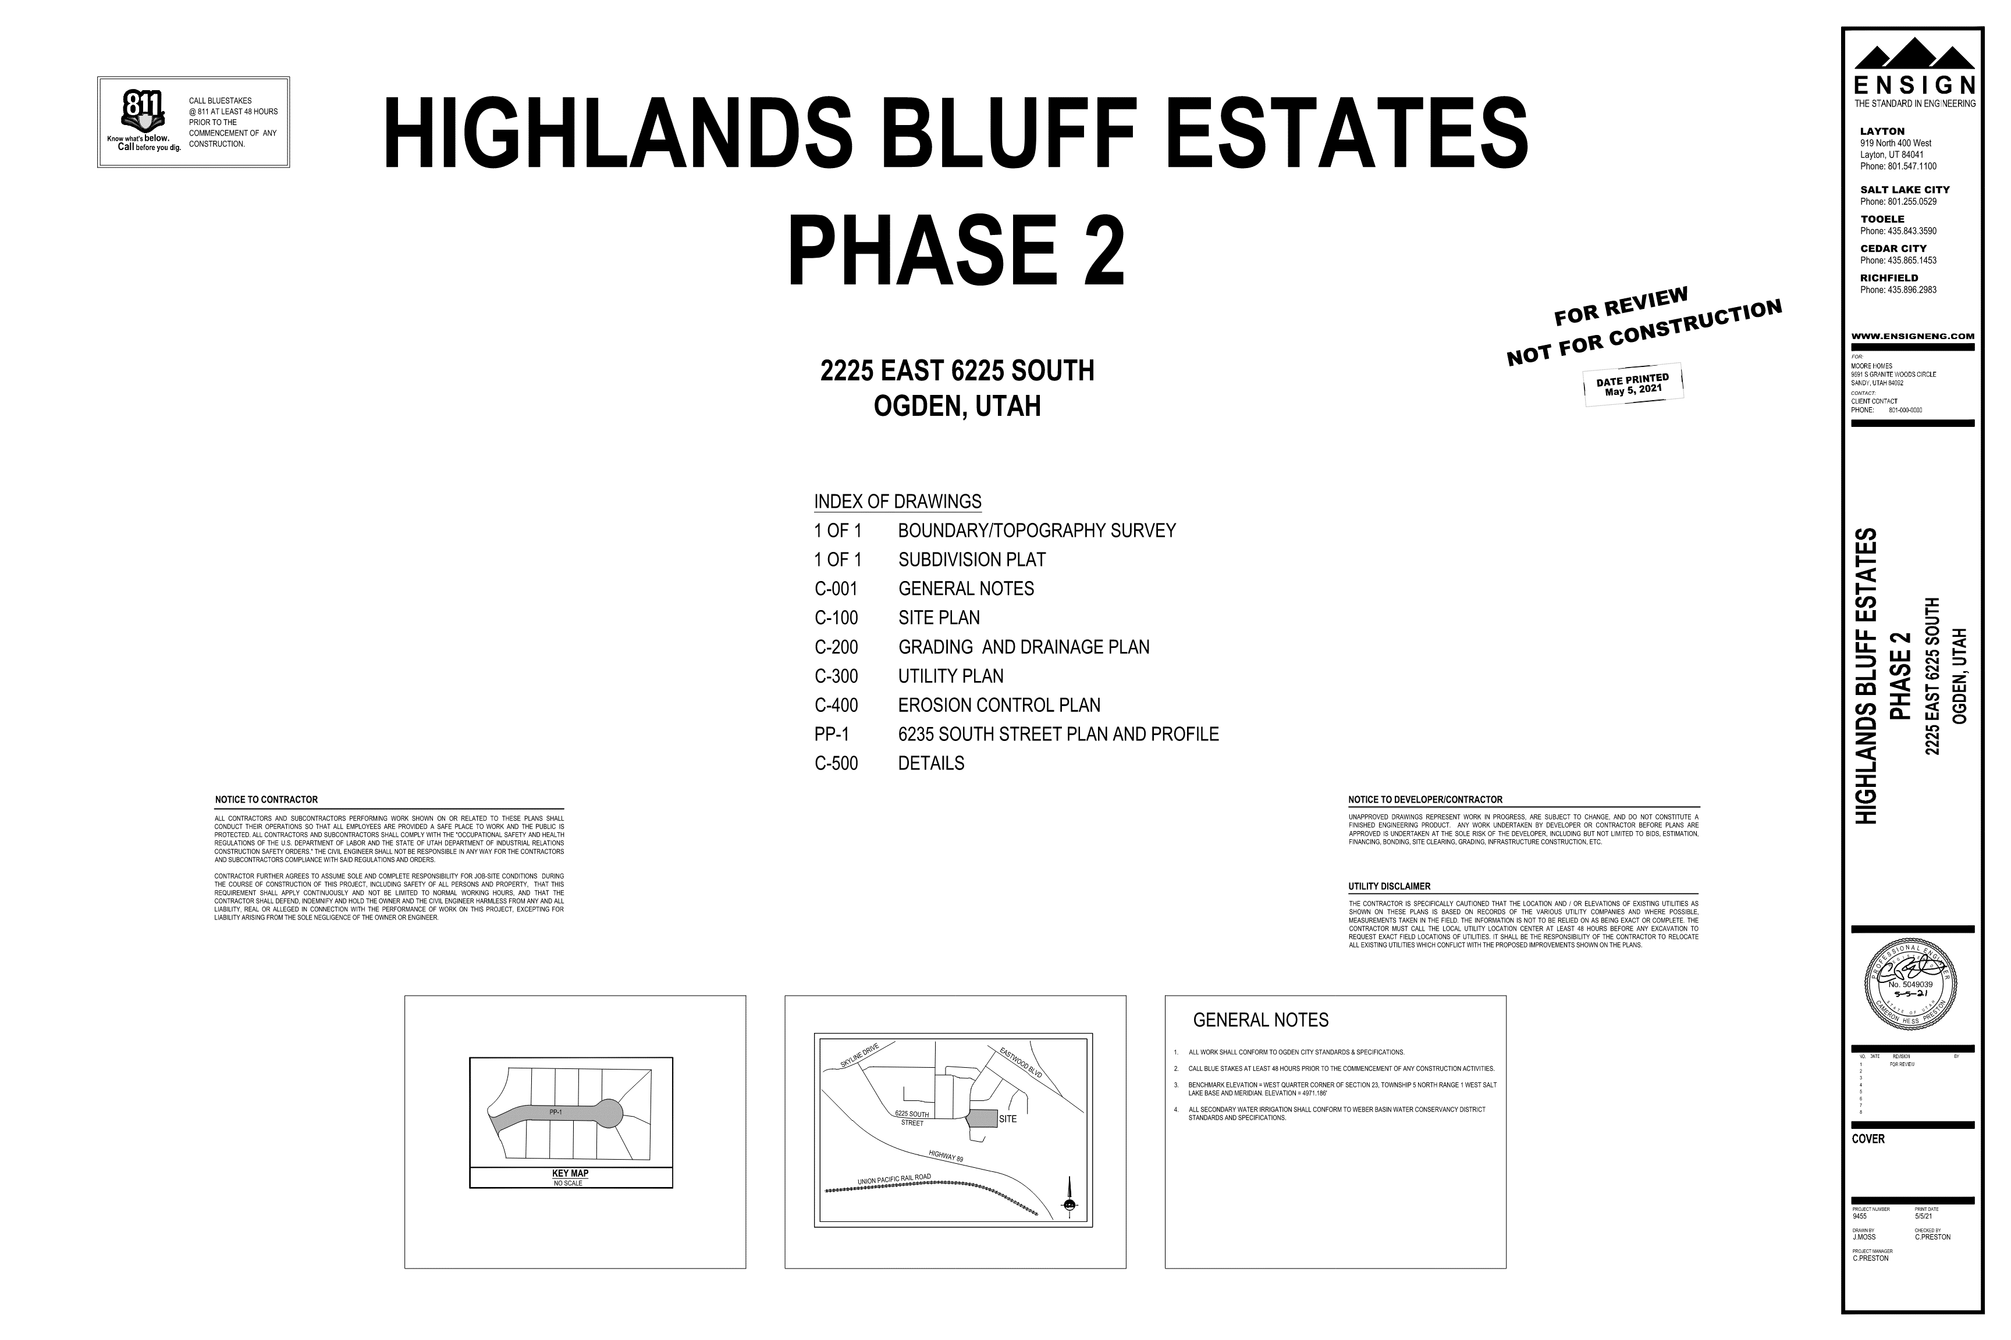 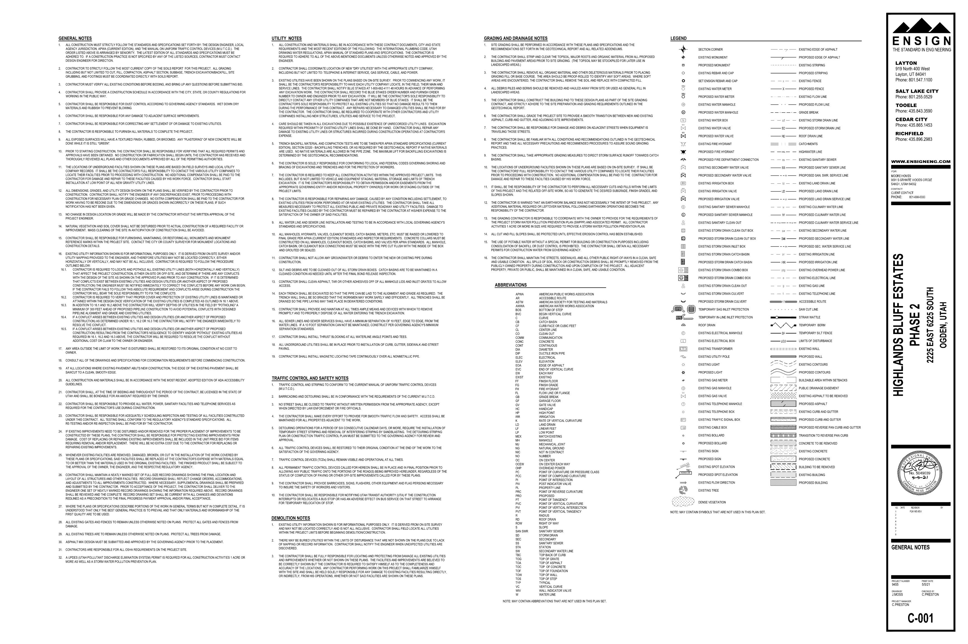

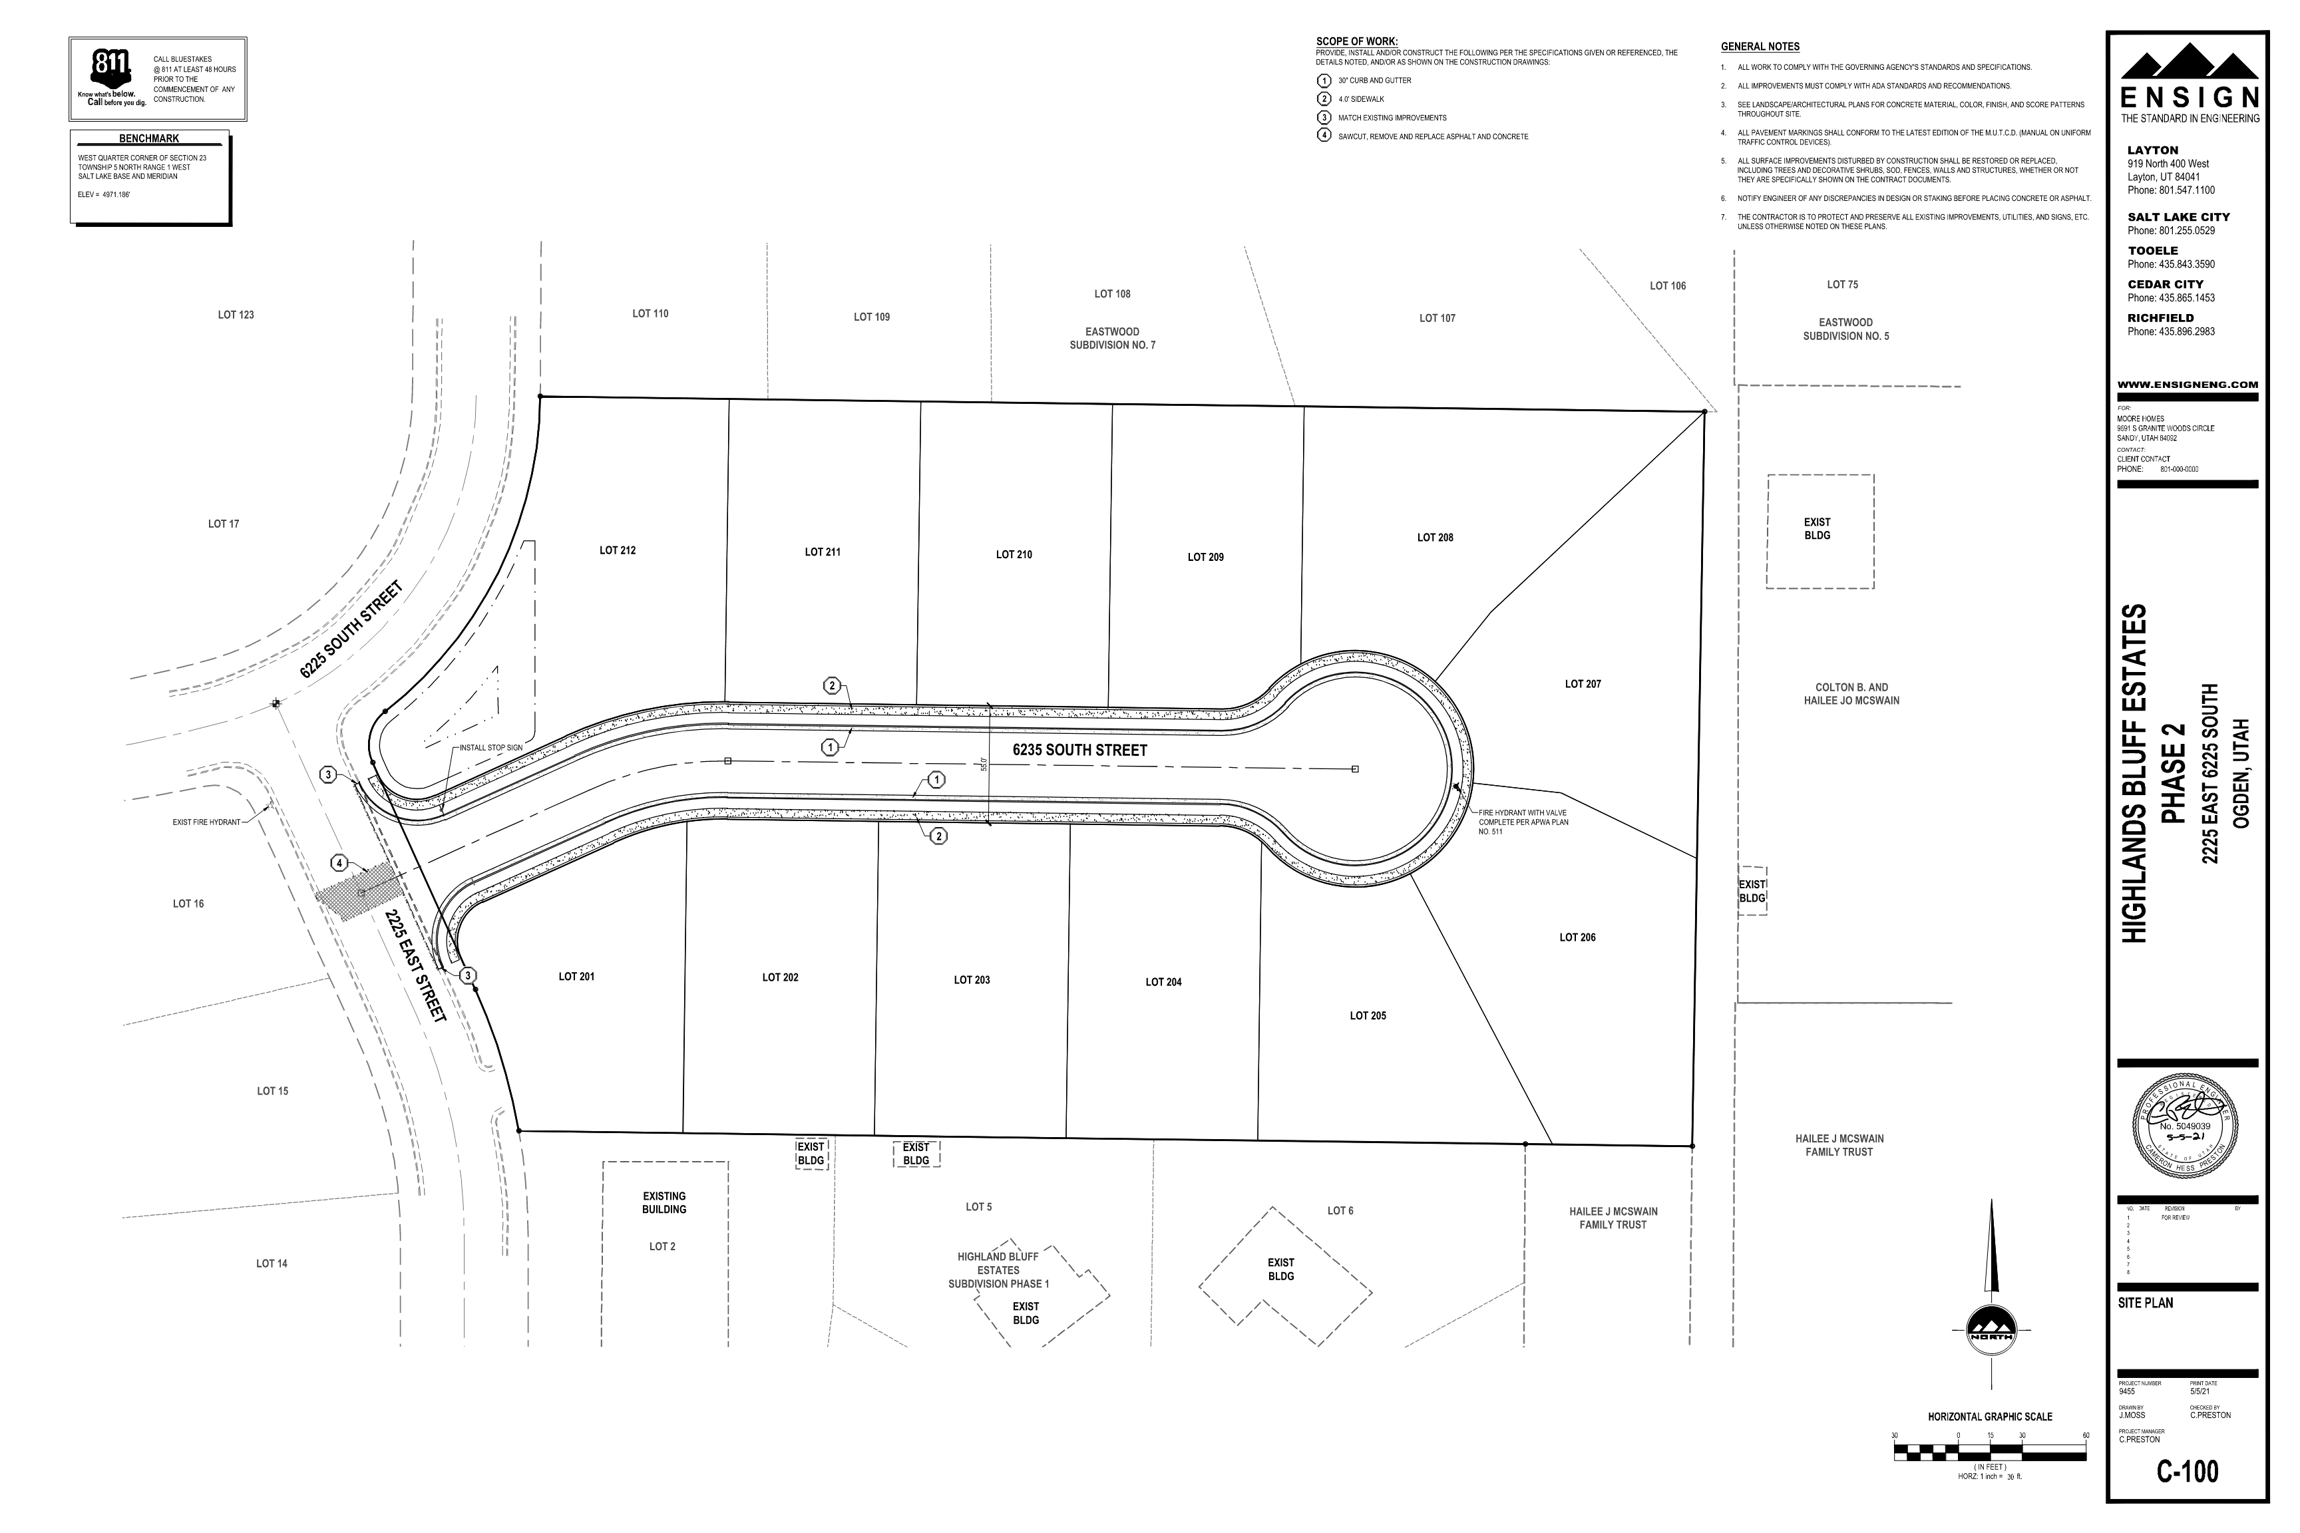 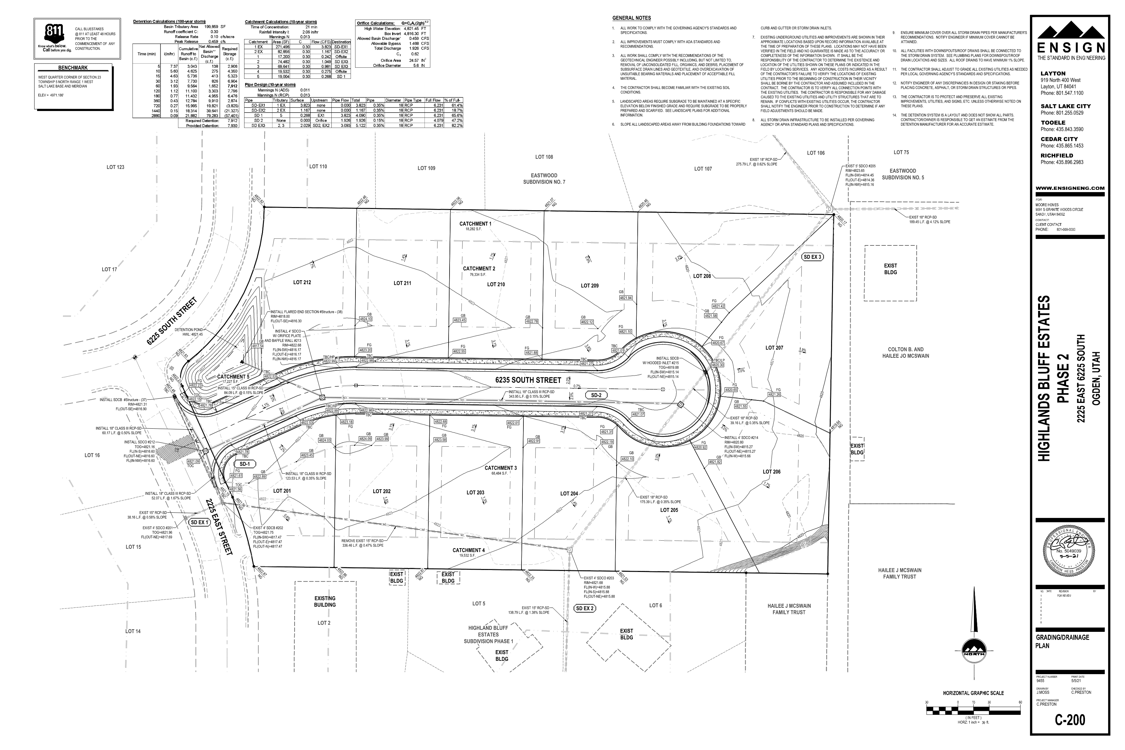 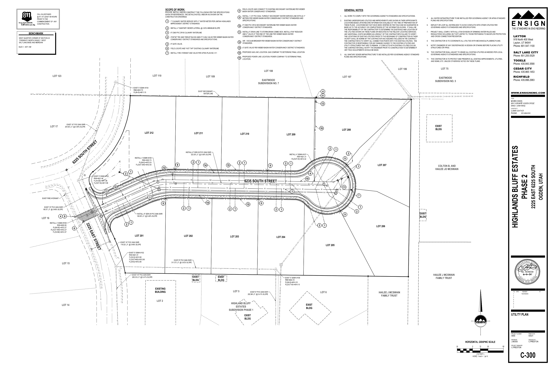 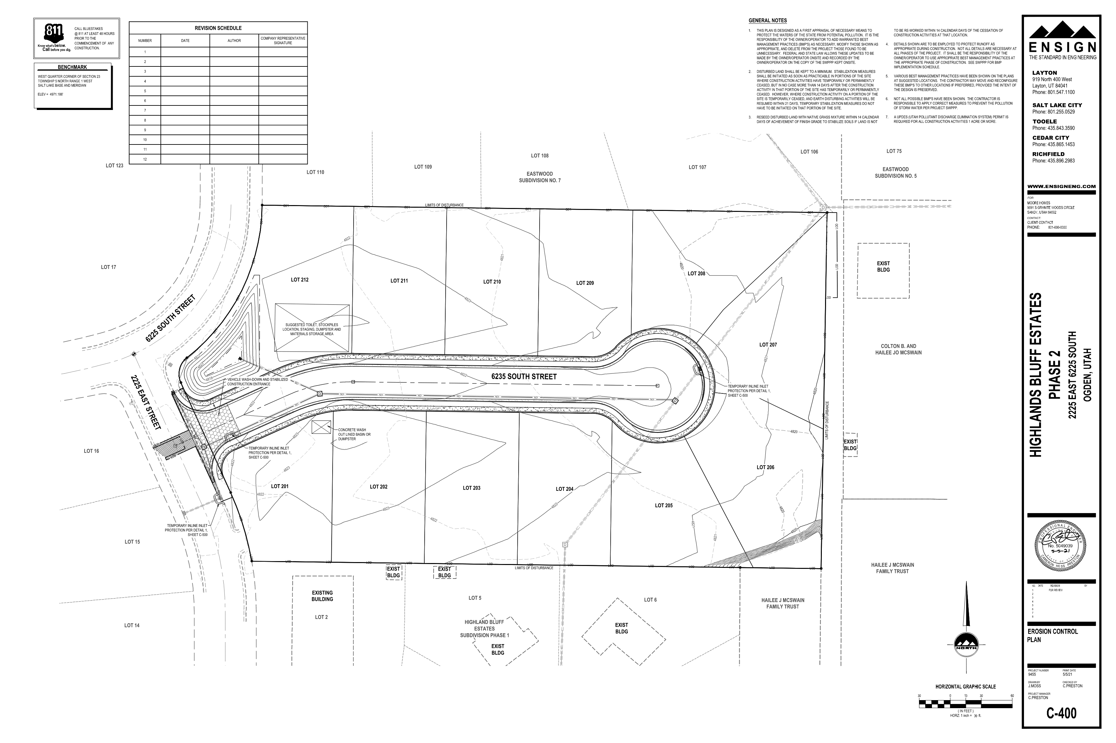 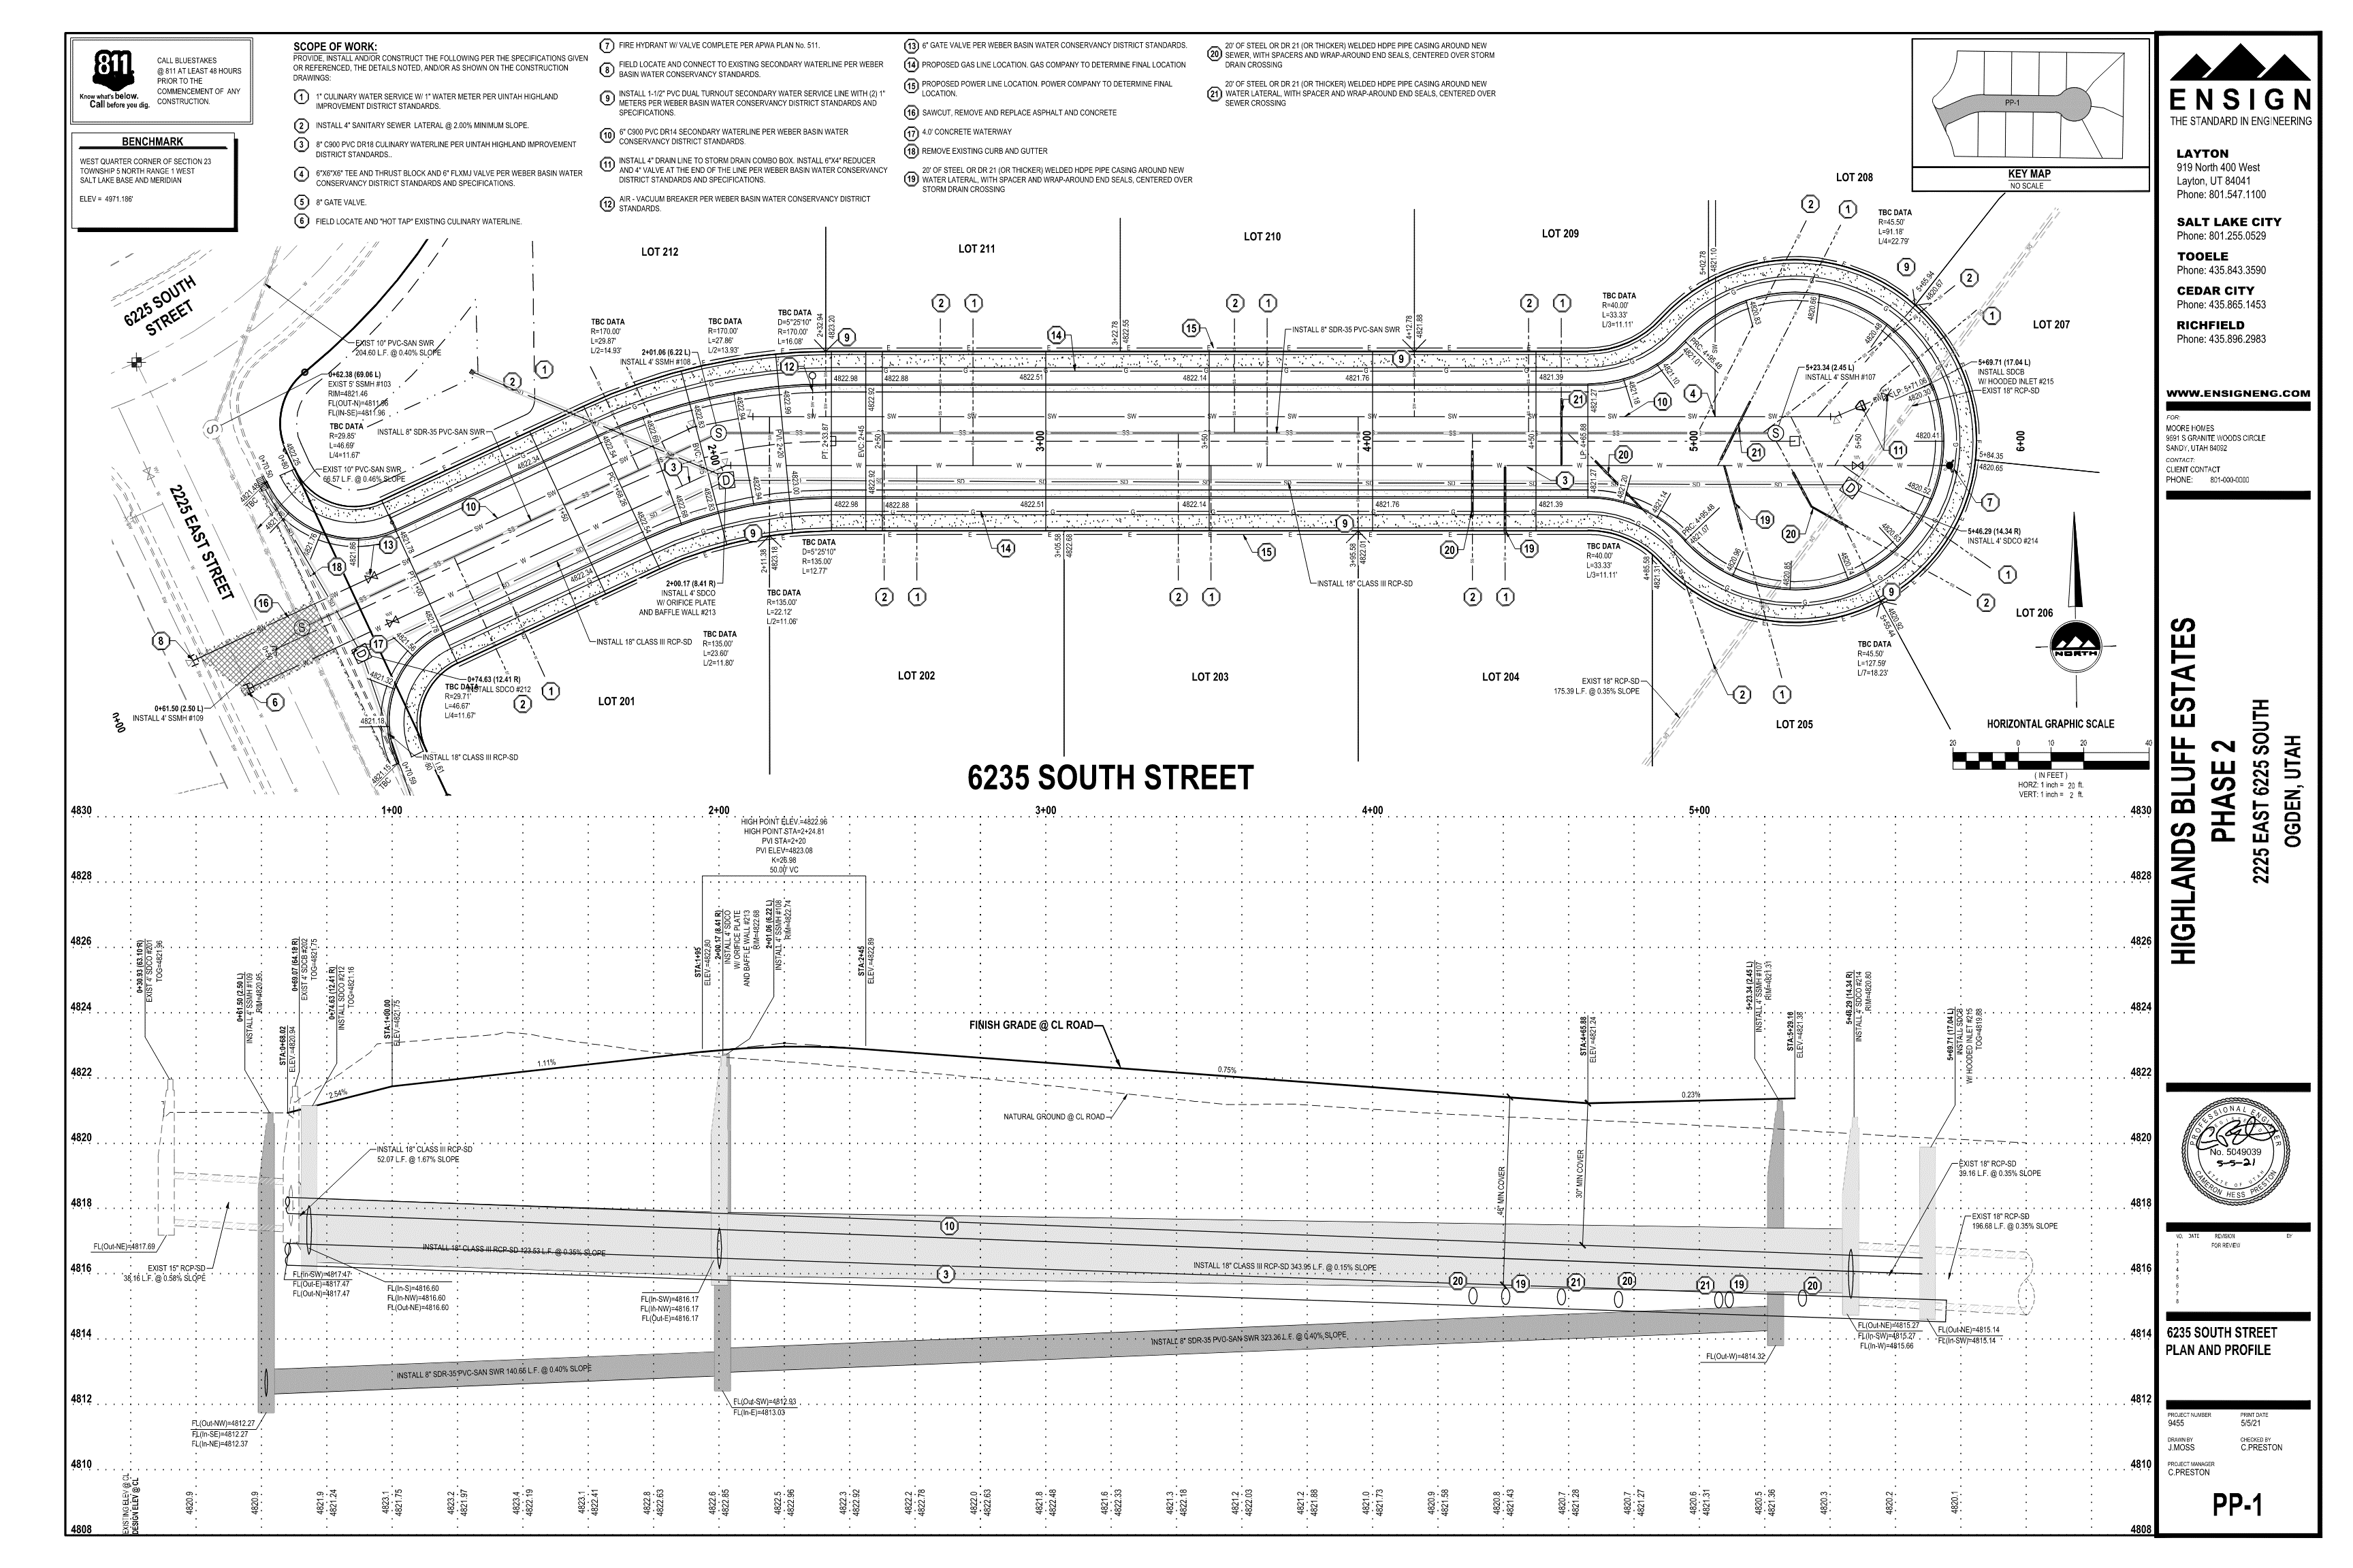 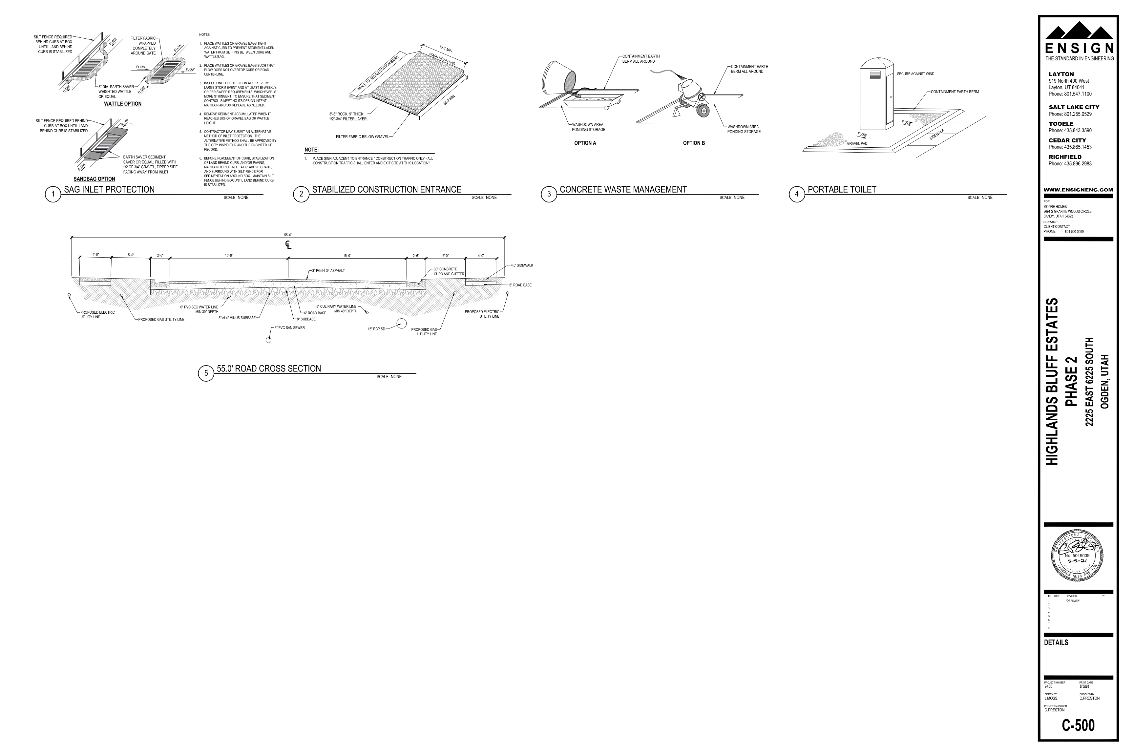

Exhibit C: Reserved for Escrow Certificate or Letter of Credit

**ESCROW CERTIFICATE**

TO WEBER COUNTY, UTAH:

The undersigned Escrow Agent does hereby certify that it has in its possession and custody, cash in the sum of $104,491.52 which said sum said Escrow Agent is holding in escrow to guarantee the installation and completion, according to Ordinance, of all on and or off-site improvements, as specified in Exhibit "B" on the following described tracts of land in Weber County, Utah to wit:

ALL OF LOT 1, HIGHLANDS BLUFF ESTATES SUBDIVISION - PHASE 1,WEBER COUNTY, UTAH.

In the event the funds so provided herein do not pay for and complete in full all of the specified improvements set forth in Exhibit "B" and as contemplated herein, then and in that event, subdivider\developer agrees to forthwith pay to Weber County all additional amounts necessary to so complete such improvements.

Said Escrow Agent hereby covenants and agrees that it will not release said funds to any person, firm or corporation (other than as is hereinafter provided) without the express written consent and direction from said Weber County, Utah, and that if said improvements are not satisfactorily installed and completed according to Ordinance within one month short of two years from the date hereof, that the said Escrow Agent will upon demand deliver said funds to said Weber County, Utah for the sole purpose of making and/or completing all of said improvements, with said County to return to the said Escrow Agent any and all funds which may prove to be in excess of the actual cost to the County to make and/or complete said improvements.

It is understood that the County may, at its sole option, extend said period of two years for such completion of such improvements upon request of the Escrow Agent or the Subdivider, if the County Commission determines that such extension is proper.

It is further understood and agreed that all matters concerning this agreement shall be subject to the pertinent provisions of the ordinances of Weber County, Utah.

DATED this day of , 20

Escrow Agent

Signature

Title:

State of Utah )

ss:

County of Weber )

On the day of , 20 appeared before me

the signer(s) of the within instrument, who duly acknowledged to me that he/she executed the same.

Notary Public

Residing at:

**\*\*\*\*\*\*\*\*\*\*\*\*\*\*\*\*\*\*\*\*\*\*\*\*\*\*\*\*\*\*\*\*\*\*\*\*\*\*\*\*\*\*\*\*\*\*\*\*\*\*\*\*\*\*\*\*\*\*\*\*\*\*\*\*\*\*\*\*\*\*\*\*\*\*\*\*\*\*\*\*\*\*\*\*\*\*\*\*\*\*\*\*\*\*\*\*\*\***

APPROVED AS TO FORM:

Weber County Attorney Date

APPROVED:

Chairperson, Weber County Commission Date

ATTEST:

Weber County Clerk